The Prep Station – Food Truck Rules and Orientation
Water Station and Food Truck Wash Pad
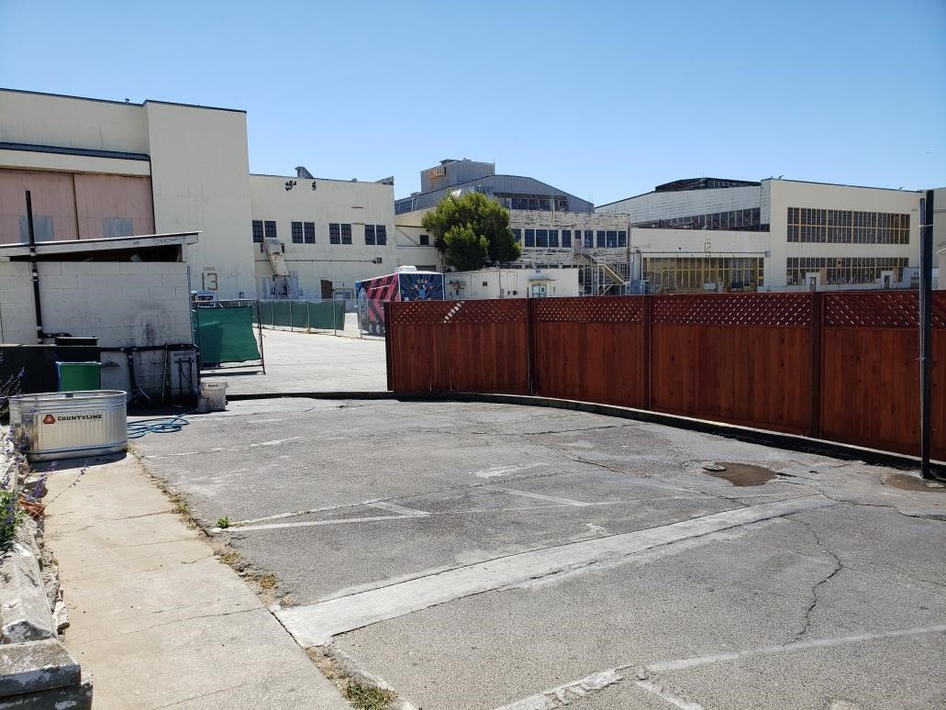
- The water station and wash pad is located at the Southwest corner of the facility

- This area is for Food Trucks only – Filling water tanks with potable water
  - Draining grey water from water tanks
  - Mopping the interior of food trucks
  - Light rinsing of exterior of food trucks

Violations of Rules regarding proper use and care of the water
station and wash pad area will yield fines of not less than
$100.00
- This is NOT A CAR WASH. There is no washing exteriors with detergents or pressure washing of food trucks

- Limit time parked on the wash pad to 45 minutes. Make room for other trucks to load and drain water when parked.

- BE RESPECTFUL of others. If you are not actively using the wash station, move your vehicle.
- There are two hoses. One is a Food Grade hose, marked by a sign “Drinking Hose”

- Hot water on the right (RED), cold water on the left (BLUE)

- Hoses must be returned and wound onto hose wheel.
- The basin next to the hose MAY NOT BE USED TO DISPOSE OF WATER OR WASTE and should be kept clean at all times
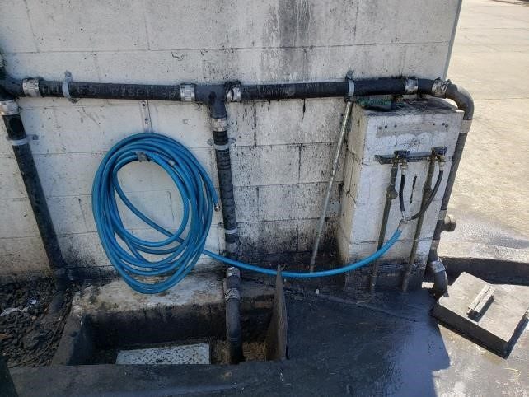
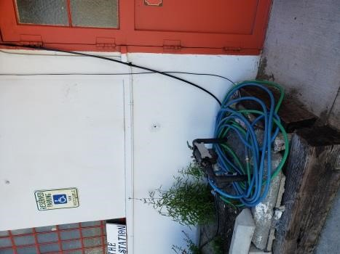
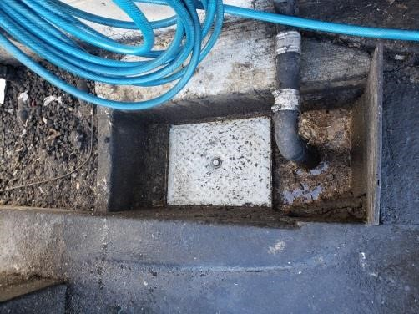
- The hose at the front entrance to the facility is NOT to be moved and is NOT FOR USE at the water station/wash pad. However, It is a food grade hose and can be used to refill drinking water.

Water Station and Food Truck Wash Pad
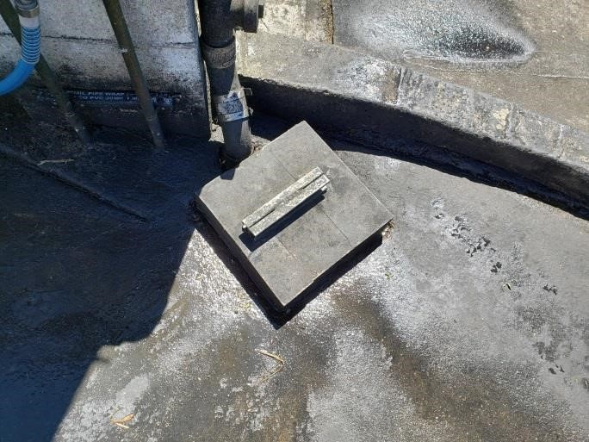
- The FLOOR SINK IS USED FOR DRAINING GREY WATER ONLY.

- No other food debris or waste may be disposed of through the floor sink

- Food trucks provide your own RV hose to drain grey water, or use buckets

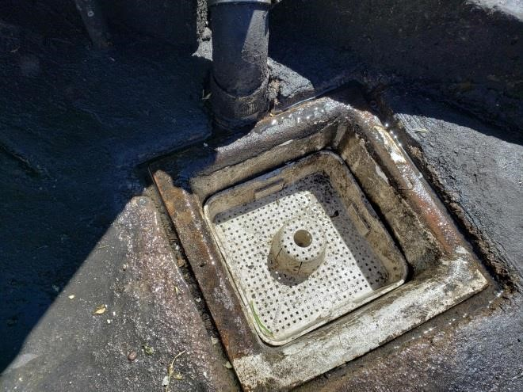
- NO GREY WATER MAY BE DRAINED ONTO THE WASH PAD or run through the sewer drain

- Food debris is collected in the sink basket and disposed of in green waste bins

- Rinse the BASKET CLEAN and replace the cover AFTER EACH USE

- The sewer drain at the front right of the wash pad is for collecting rinse water only

- No food debris or greasy water should be run through the sewer drain

- All debris must be swept clean of the basin around the sewer drain and disposed of after each use of the wash pad.

- Food trucks may be rinsed clean, but NO DETERGENT AND NO PRESSURE WASHING IS ALLOWED. THIS IS NOT A CAR WASH

- There is NO SOAKING OR WASHING OF GREASE BAFFLES on the wash pad. Use inside sinks.
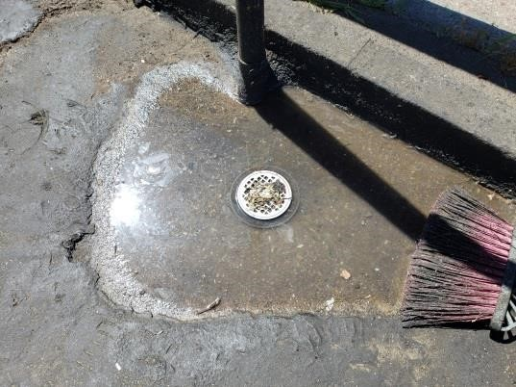
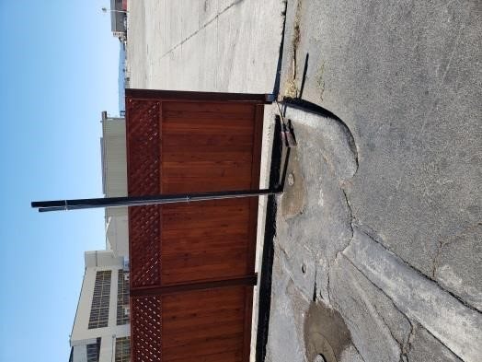
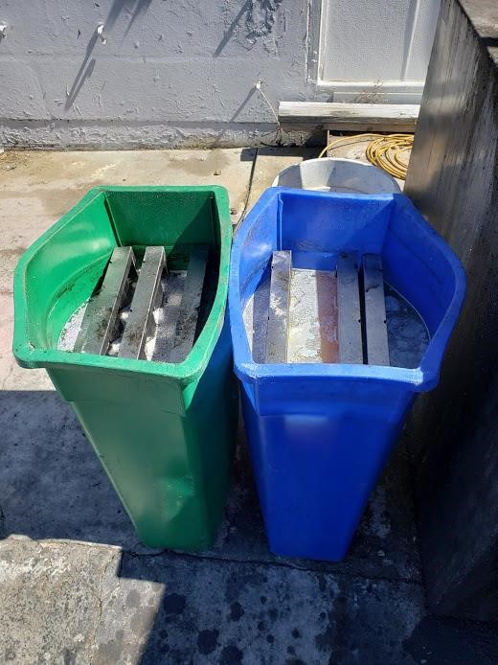

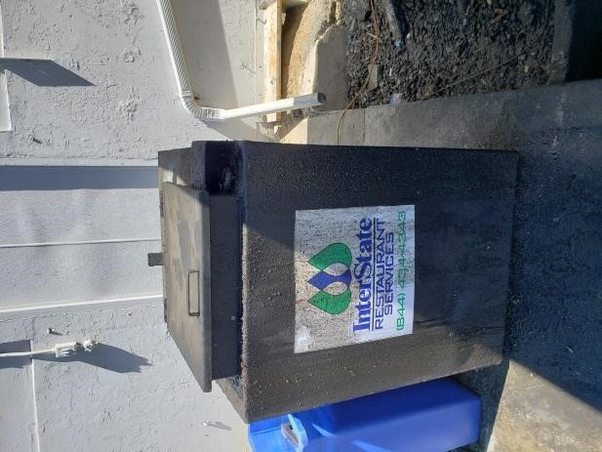
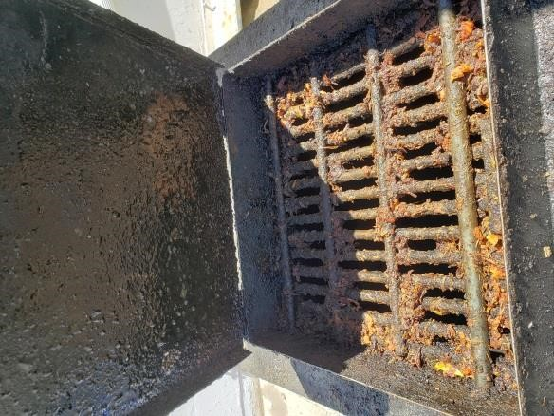
- There is a cooking oil recycling drums located at the wash pad

- The drums are for cooking oil only, and may not be used to dispose of any other waste material

- Keep the lid on the drums closed at all times

- Minimize food waste poured through the grate into the cooking oil container

- NO FOOD WASTE LEFT ON THE COLLECTION
GRATE. Scrape the grate clean and dispose of food waste in green waste bins after each use.

- If you spill cooking oil on the bin or ground, use kitty litter (located in marked container in the wash station area) to soak up excess oil and dispose of it in the garbage

- ALL MEMBERS of The Prep Station are required to keep areas clean and tidy. This is a professional workplace. The facility is inspected on a regular basis. We expect all of our vendors to pass food and safety standards.

- Members will be fined upon violation of rules and guidelines. Please make sure you have read through protocol and understand how to operate within our kitchen and grounds.

